|  |  |  |  |  |  |  |  |  |  |  |  |  |  |  |  |  |
| --- | --- | --- | --- | --- | --- | --- | --- | --- | --- | --- | --- | --- | --- | --- | --- | --- |
| NumeroCaseID | Dispute Type | Status | CustomerID | DisputeID | TitleOther | Forname | Surname | Composite Name | DoB | DobOther | ResidenceID | House Number | Street | Town | PostCode | CCJCasePerID |
| 23 | 601 | SA | 200000 | 3773777 | MRS | VICKY | TENNIS | MRS VICKY TENNIS | 23/01/1975 | 1975-01-23 | 169068275 | 63 | THE RIDGE | STOCKPORT | SK6 7ER | 80004459 |
| 24 | 602 | JG | 200001 | 3773778 | MR | BILL | BOXING | MR BILL BOXING | 07/07/1969 | 1969-07-07 | 169068276 | 65 | THE RIDGE | STOCKPORT | SK6 7ER | 80004460 |
| 25 | 604 | SA | 200002 | 3773779 | MR | TOM | HOOVER | MR TOM HOOVER | 09/04/1981 | 1981-04-09 | 169068277 | 61 | THE RIDGE | STOCKPORT | SK6 7ER | 80004461 |
| 26 | 605 | JG | 200003 | 3773780 | MR | COLIN | HOTPOINT | MR COLIN HOTPOINT | 12/11/1965 | 1965-11-12 | 169068278 | 63 | THE RIDGE | STOCKPORT | SK6 7ER | 80004462 |
| 27 | 606 | JG | 200004 | 3773781 | MR | GEORGE | BEKO | MR GEORGE BEKO | 14/03/1987 | 1987-03-14 | 169068279 | 65 | THE RIDGE | STOCKPORT | SK6 7ER | 80004463 |
| 28 | 607 | JG | 200005 | 3773782 | MRS | EMMA | INDESIT | MRS EMMA INDESIT | 27/07/1979 | 1979-07-27 | 169068280 | 61 | THE RIDGE | STOCKPORT | SK6 7ER | 80004464 |
| 29 | 609 | JG | 200006 | 3773783 | MRS | DEBBIE | BOSCH | MRS DEBBIE BOSCH | 03/01/1990 | 1990-01-03 | 169068281 | 63 | THE RIDGE | STOCKPORT | SK6 7ER | 80004465 |
| 30 | 610 | JG | 200007 | 3773784 | MR | ALAN | LOGIK | MR ALAN LOGIK | 16/04/1972 | 1972-04-16 | 169068282 | 65 | THE RIDGE | STOCKPORT | SK6 7ER | 80004466 |

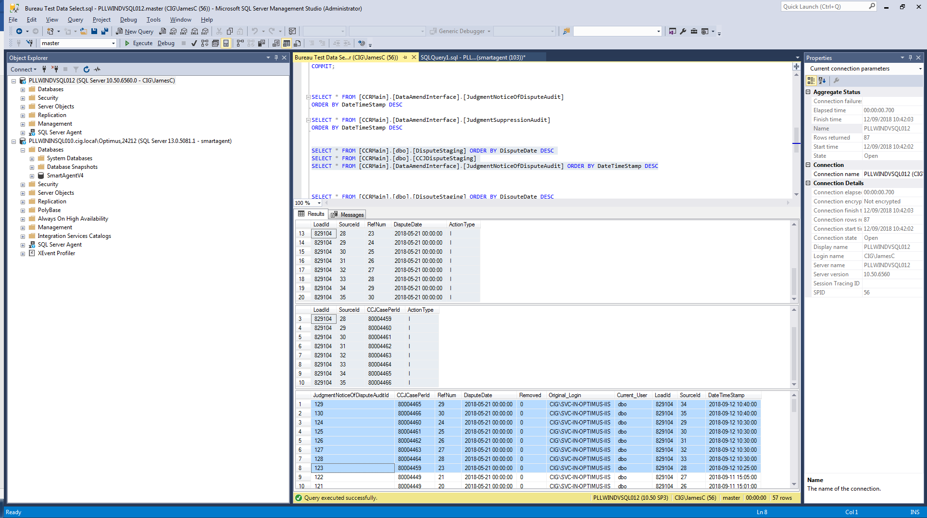

LoadId SourceId RefNum DisputeDate ActionType

829104 28 23 2018-05-21 00:00:00 I

829104 29 24 2018-05-21 00:00:00 I

829104 30 25 2018-05-21 00:00:00 I

829104 31 26 2018-05-21 00:00:00 I

829104 32 27 2018-05-21 00:00:00 I

829104 33 28 2018-05-21 00:00:00 I

829104 34 29 2018-05-21 00:00:00 I

829104 35 30 2018-05-21 00:00:00 I